Major Tables Used in this phase so far

Table 1: Dataset Split Summary
Table 1: Distribution of Dataset Used for Model Training and Evaluation
Dataset Split | Number of Samples | Percentage
Training Set | 319 | 80%
Test Set | 81 | 20%
Total | 400 | 100%

“Table 1 presents the distribution of the cleaned and balanced dataset used in this study. The dataset was stratified to maintain equal representation of fake and true news across training and test sets.”

Table 2: Overall Model Performance Metrics
Table 2: Performance Metrics of the Baseline Logistic Regression Model
Metrics | Scores
Accuracy | 92.59%
Precision | 92.68%
Recall | 92.68%
F1-score | 92.68%
“Table 3 presents class-wise evaluation results for fake and true news classification using the baseline Logistic Regression model.”

Figure 1: Class Distribution
Figure 1: Distribution of Fake and True News in the Dataset

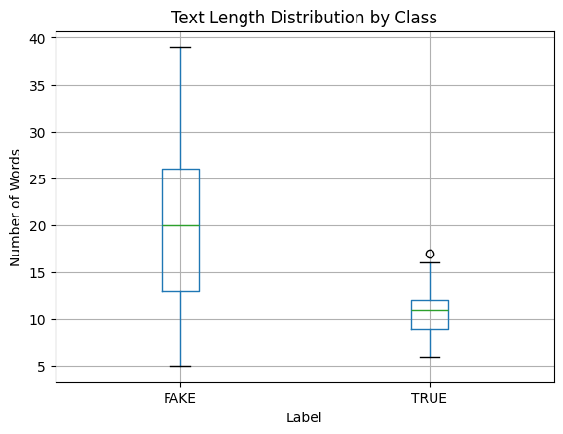
Figure 1 illustrates the balanced distribution of fake and true news samples used in this study, ensuring that the model is not biased toward any single class.

Figure 2: Evaluation Metrics Comparison
Figure 2: Performance Metrics of the Baseline Model

Figure 3: Confusion Matrix
Figure 3: Confusion Matrix for Fake News Detection
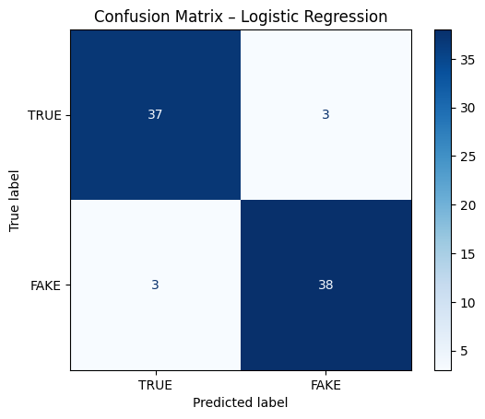
Figure 3 illustrates the confusion matrix of the Logistic Regression model, showing correct and incorrect classifications for fake and true news samples.

Conclusion
The baseline Logistic Regression model achieved strong performance across all evaluation metrics, with an overall accuracy of approximately 93%. Precision, recall, and F1-score values were consistent across both fake and true news classes, indicating balanced classification performance. These results demonstrate that even a simple linear classifier, when combined with TF-IDF feature extraction and well-curated local data, can effectively detect fake news in the Ugandan context. The findings validate the suitability of the dataset and provide a solid foundation for experimenting with more advanced models in subsequent research phases.

